Running APP: https://github.com/dpercoco/CRUDDemo (dpercoco@comcast.net/1nv13rn0)
AMX Pages: https://github.com/dpercoco/CRUDDemo/tree/master/ViewController/public_html/crud.Recipes
Java Code: https://github.com/dpercoco/CRUDDemo/tree/master/ViewController/src/crud/JAVA
SDK Folder: C:\MyApps\Android\sdk2\ - secondary C:\Users\p62680o\AppData\Local\Android\sdk
Top of Form
Bottom of Form

Failed to restart the ADB server. (oracle.adfmf.framework.dt.deploy.android.deployers.MaybeStartupAdbServerDeployer)

Reference: https://docs.oracle.com/cd/E53569_01/tutorials/tut_jdev_maf_setup/tut_jdev_maf_setup_2.html
- Make sure you are using JDeveloper Studio Edition Version 12.2.1.0.0
- Android Studio 2.3.2 (android-studio-bundle-162.3934792-windows.exe)
- Look at Android Studio & JDeveloper Setting (below)
TO START SERVER from COMMAND LINE:
End task "adb.exe" background process from task manager.
cd SDK Folder\platform-tools\
adb kill-server
adb start-server
adb restart
adb devices
..\emulator\ emulator.exe -netdelay none -netspeed full -avd Nexus_5X_API_25_2_2018_

STEP 1: Launching Emulator via Android Studio Nexus_5X_API_25
Run "C:\MyApps\Oracle\androidEmulator.bat"
SDK Folder\emulator\emulator.exe -netdelay none -netspeed full -avd Nexus_5X_API_25_2_2018_

For a list of devices:
emulator -list-avds
C:\MyApps\Android\sdk\platform-tools\adb devices
OR
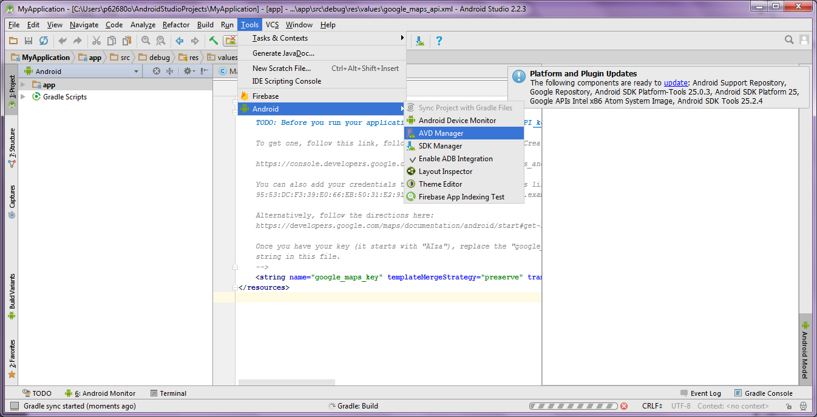
Viewing Oracle JDeveloper Android Settings
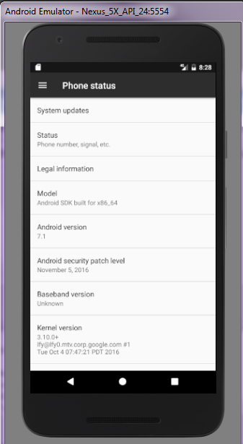
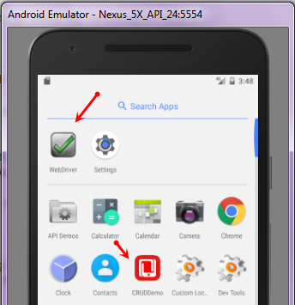

STEP2: Start Oracle JDeveloper, Deploy App
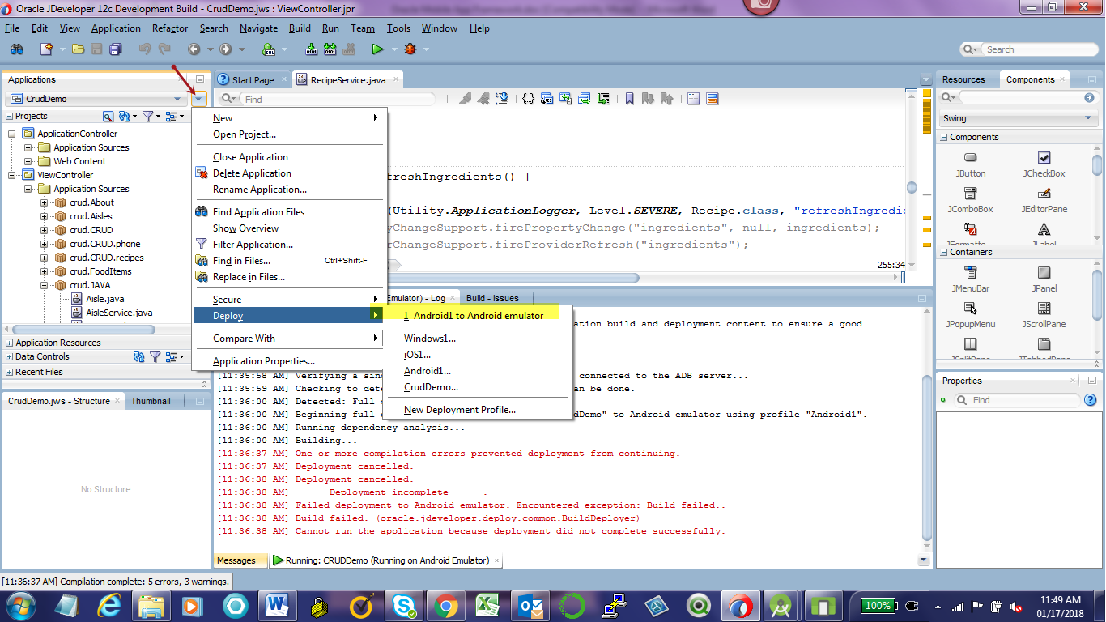
Working with current Entity (e.g. Delete Recipe) – Method 1
RecipeService.java
- Create Method ‘setRecipe’ to create ‘recipe’ object
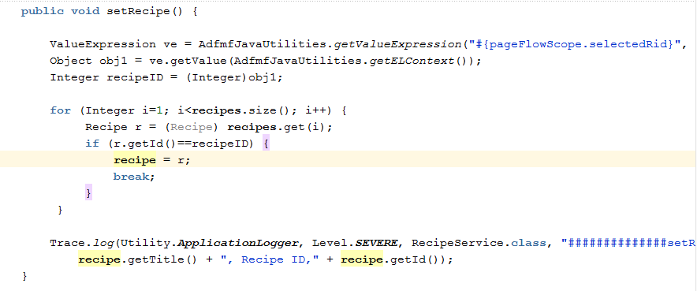
- Create Method ‘deleteRecipe
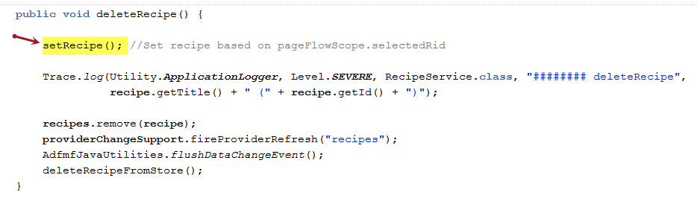
- Ensure these methods exist.
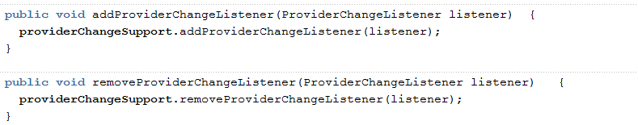
ListRecipe.amx
- In ‘listView’ add ‘actionListener’
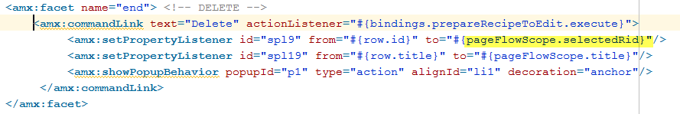
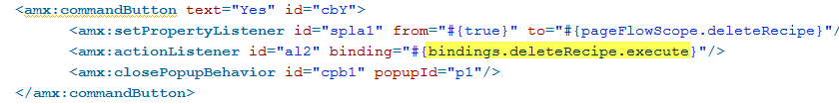
- Or you can do it all at once
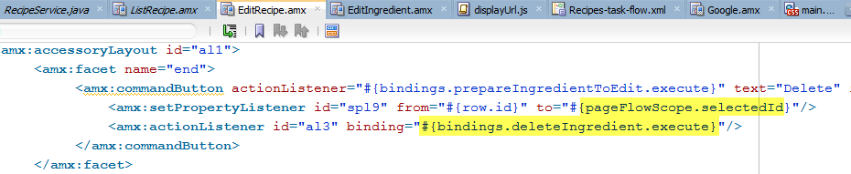
Working with current Entity (e.g. Delete Recipe) – Method 2
RecipeService.java
- Create Method ‘prepareRecipeToEdit’
- Ensure these methods exist
- Create deleteRecipe Method
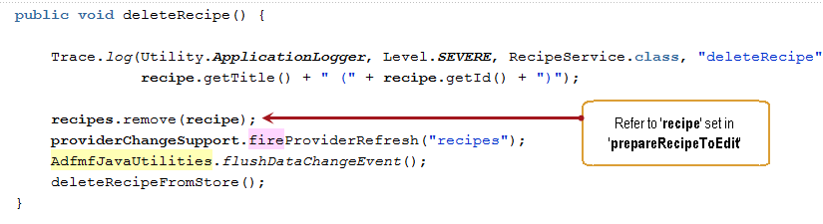
ListRecipe.amx
- In ‘listView’ add ‘actionListener’
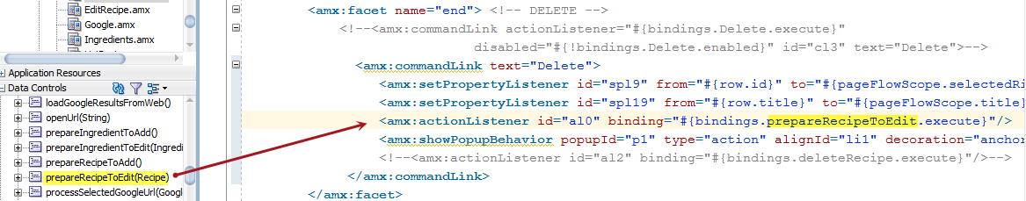

"bindings.recipesIterator.currentRow.dataProvider"
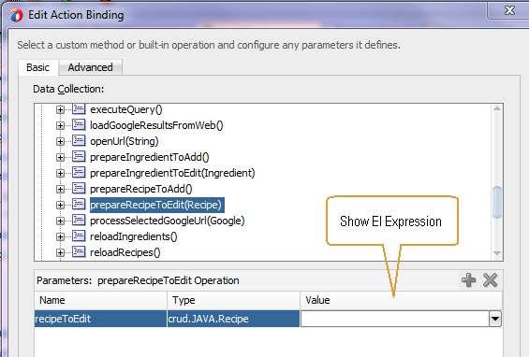
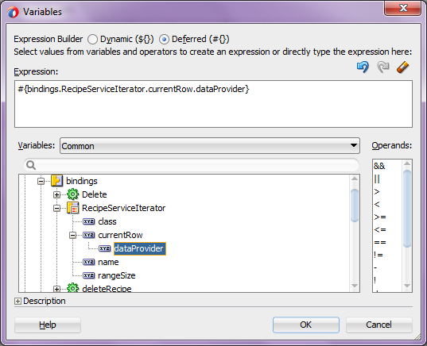
"bindings.recipesIterator.currentRow.dataProvider"

- Add command to delete recipe
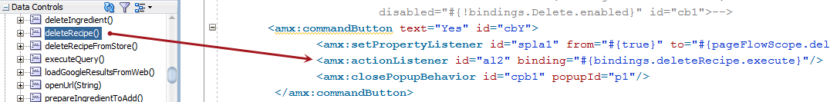

Java JDK (software install):
http://www.oracle.com/technetwork/java/javase/downloads/jdk-netbeans-jsp-142931.html
http://javadl.sun.com/webapps/download/AutoDL?BundleId=76209 (Version 1.6)
https://www.iconfinder.com/icons/85180/close_icon (icons)
https://docs.oracle.com/middleware/1212/skineditor/
http://flexagon.com/2014/10/create-adf-skin-for-styling-your-adf-applications/
Selenium WebDriver (install)
http://www.seleniumhq.org/projects/webdriver/
http://www.automationace.com/2014/03/steps-to-install-selenium-webdriver-on_8923.html
DOS commands: (Invoked from folder: SDK Folder\platform-tools)
adb devices
adb -s emulator-5554 -e install –r android-server.apk
adb -s emulator-5554 shell am start -a android.intent.action.MAIN -n org.openqa.selenium.android.app/.MainActivity

shell am start -a android.intent.action.MAIN -n org.openqa.selenium.android.app/.MainActivity
$./adb -s <serialId> forward tcp:8080 tcp:8080

adb forward tcp:8080 tcp:8080

set ANDROID_HOME= SDK Folder
set PATH=%PATH%;%ANDROID_HOME%\tools;%ANDROID_HOME%\platform-tools

java -jar selendroid-standalone-0.17.0-with-dependencies.jar -app selendroid-test-app-0.17.0.apk

[http://stackoverflow.com/questions/8644992/error-registry-key-software-javasoft-java-runtime-environment-currentversion] (Set Java Current Version)

https://github.com/RaveeBellur/Android/blob/master/Android%20Emulator/src/com/demo/tests/testSearchFunctionality.java (performing WebDriver Searches)
http://www.java2s.com/Code/Jar/s/Downloadseleniumandroiddriverjar.htm (selenium-android-server.jar)
http://www.java2s.com/Code/Jar/s/Downloadseleniumapijar.htm
https://jar-download.com/?search_box=selenium-htmlunit-driver
https://github.com/akiellor/selenium/tree/master/android/prebuilt (android-server.apk)
https://sourceforge.net/projects/htmlunit/files/htmlunit/2.23/htmlunit-2.23-OSGi.jar/download
http://htmlunit.sourceforge.net/ (documentation)
http://htmlunit.sourceforge.net/gettingStarted.html (imitating a specific browser)
http://stackoverflow.com/questions/16636482/htmlunit-change-user-agent-string

Oracle Mobile App Framework:
http://www.oracle.com/technetwork/developer-tools/jdev/downloads/jdev12210download-3046390.html (JDeveloper)
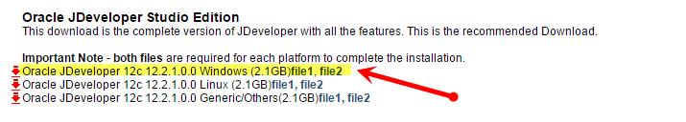
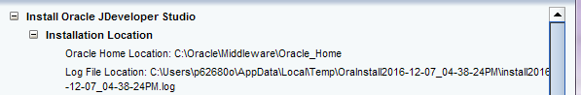



Source code:
C:\Oracle\JDeveloper\mywork\shoppingList\shopView(ViewController)\src\shopMobile C:\Oracle\SampleApps\CRUDDemo\ViewController\src\crudmodel
Creating the Database:
C:\Oracle\SampleApps\CRUDDemo\.adf\META-INF\people.sql
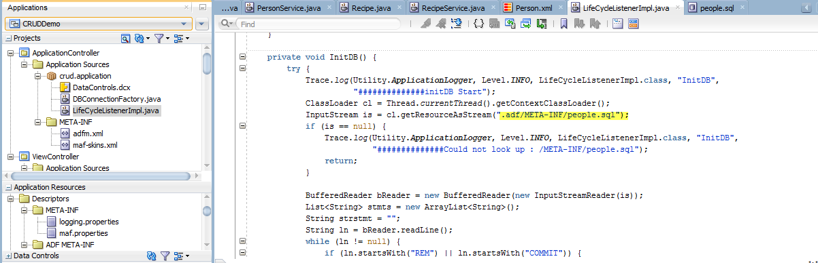
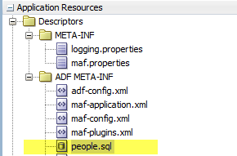
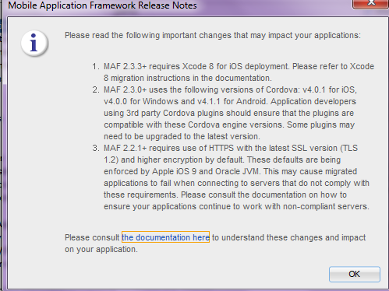
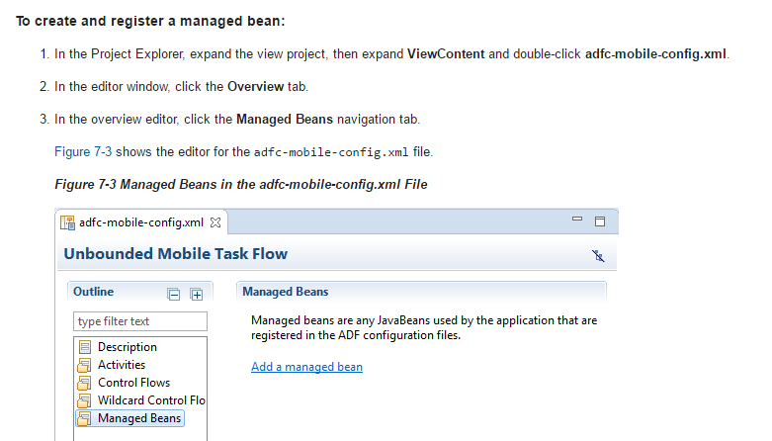

http://download.oracle.com/otn_hosted_doc/jdeveloper/11gdemos/adfmobiledemo/adfmobiledemo.html
http://www.oracle.com/technetwork/developer-tools/jdev/overview/index.html
https://docs.oracle.com/middleware/maf212/mobile/develop-maf/appx-maf-xml-files.htm#ADFMF25164 (framework)
https://docs.oracle.com/middleware/maf210/mobile/develop-maf/maf-apps-editing.htm#ADFMF192 (Configure application)
http://www.oracle.com/technetwork/developer-tools/maf/learnmore/mafsamples-2227357.html (Description of Samples)
http://docs.oracle.com/cd/E18941_01/tutorials/setupmobileapps/jdtut_11r2_54_2.html
http://docs.oracle.com/cd/E53569_01/tutorials/tut_jdev_maf_spring/tut_jdev_maf_spring.html (Developing a Custom Springboard)
http://docs.oracle.com/middleware/mobile200/mobile/develop/maf-debug-test.htm#BABIHBID (Debugging)
http://www.oracle.com/technetwork/developer-tools/jdev/urldatacontrol-099677.html (working with RSS Feeds)
https://www.tutorialspoint.com/android/android_rss_reader.htm (RSS)
http://docs.oracle.com/cd/E18941_01/tutorials/jdtut_11r2_10/jdtut_11r2_10.html (RSS Feeder)
https://docs.oracle.com/middleware/maf212/mobile/develop-maf/maf-sqlite-db.htm#ADFMF23706 (Initialize databases)
https://docs.oracle.com/middleware/maf220/mobile/develop-maf/GUID-13EC7791-CBA5-4548-9E8B-B3091E5FFE21.htm#ADFMF1646 (DeviceDemo – to display files)
http://andrejusb.blogspot.com/2011/10/iphone-web-application-development-with.html (Using Web Browser)
http://andrejusb.blogspot.com/2012/12/adf-mobile-geo-location-and-google-maps.html
http://www.awasthiashish.com/2014/05/reading-html-source-of-webpage-url.html
https://docs.oracle.com/middleware/maf231/mobile/develop-maf/GUID-74D1067F-9040-4490-BA9A-172E376C478F.htm#ADFMF24712 (Proxy settings)
http://stackoverflow.com/questions/1432961/how-do-i-make-httpurlconnection-use-a-proxy
http://stackoverflow.com/questions/4599933/how-to-use-an-http-proxy-in-java
http://myfusionlearnings.blogspot.com/2016/02/adding-custom-cssskin-file-to-maf.html (Customizing your own CSS style sheet)
http://andrejusb.blogspot.com/2011/10/iphone-web-application-development-with.html (Deployment to IOS)
http://stackoverflow.com/questions/3727662/how-can-you-search-google-programmatically-java-api (Searching Google)
http://docs.oracle.com/cd/E53569_01/tutorials/tut_jdev_maf_json/tut_jdev_maf_json_3.html (Adding employee)
https://github.com/oracle/mobile-persistence/wiki/Using-the-Entity-Service-Data-Control (Filtering)
https://docs.oracle.com/cd/E35521_01/doc.111230/e24475/amxui.htm#ADFMF567 (Checkboxes)
https://blogs.oracle.com/mobile/entry/how_to_open_and_close (PopUps)
https://blogs.oracle.com/shay/entry/refreshing_a_part_of_your_page_1 (Refresh after PopUp Closes)
http://stackoverflow.com/questions/32503754/how-to-change-background-color-while-clicking-link-or-button (Change popup color)
http://andrejusb.blogspot.com/2015_03_01_archive.html
http://www.oracle.com/webfolder/ux/mobile/component/popup.html
http://www.adfwithnitish.com/2013/08/creating-custom-column-filter-in-adf.html
https://blogs.oracle.com/emeapartnerweblogic/entry/using_refresh_container_component_in
https://blogs.oracle.com/shay/entry/dynamically_refresh_a_part_of (REFRESH - showIt)
https://blogs.oracle.com/shay/dynamically-refresh-a-part-of-a-page-ppr-in-oracle-maf (Use Backing Bean to hide a row – JAN 2018)
https://docs.oracle.com/cd/E53569_01/tutorials/tut_jdev_maf_json/tut_jdev_maf_json_3.html (Using Backing Bean to setup listView actionListener – JAN 2018)
http://bloggers1033.rssing.com/chan-5781190/all_p705.html (Managed Bean)
https://docs.oracle.com/middleware/maf232/mobile/develop-oepe/GUID-5B984654-52ED-4E54-8879-F44213506ED3.htm#OEPMF730 (fireProviderDelete)
https://github.com/oracle/mobile-persistence/wiki/Using-the-Entity-Service-Data-Control (Filtering the listview)
http://waslleysouza.com.br/en/2015/10/using-refresh-container-component-in-maf/
http://waslleysouza.com.br/en/2014/12/restjson-in-maf/ (MAFRESTJSONApp.zip)
http://www.oracle.com/webfolder/ux/mobile/component/pulltorefresh.html
https://blogs.oracle.com/emeapartnerweblogic/entry/using_refresh_container_component_in
https://github.com/oracle/mobile-persistence/wiki/Using-the-StorageObjectService-Bean-Data-Control (Reading from storage files)
https://blogs.oracle.com/mobile/entry/quick_tip_changing_button_icon (Backing Bean)
http://docs.oracle.com/cd/E53569_01/tutorials/tut_jdev_maf_json/tut_jdev_maf_json_2.html (Using REST/SOAP)
http://docs.oracle.com/middleware/mobile201/mobile/develop/maf-web-services.htm#CHDDGEHF (Web Service)
https://blogs.oracle.com/mobile/entry/quick_tip_changing_button_icon
https://blogs.oracle.com/mobile/entry/accessing_selected_values_in_a (Select Many Checkbox)
http://prsync.com/oracle/how-to-access-selected-values-in-a-multi-select-list-668104/ (multi-select Backing Bean)
https://www.programcreek.com/java-api-examples/index.php?source_dir=mobile-persistence-master/Projects/Framework/Runtime/src/oracle/ateam/sample/mobile/persistence/service/EntityCRUDService.java (Sample Code using a Persistence Manager)

http://docs.oracle.com/cd/E53569_01/tutorials/tut_jdev_maf_json/tut_jdev_maf_json_3.html
http://deepakcs.blogspot.com/2013_03_01_archive.html (Using iterator, Value Expression, Device Back Button)
https://knowldege2spread.wordpress.com/2015/10/20/getting-values-of-the-selected-check-box-in-maf-application/
http://deepakcs.blogspot.com/2013/02/adf-mobile-iterate-through-all-rows-in.html (Iteration)
https://community.oracle.com/thread/4000059 (Create collapse/expand sections)
https://java.net/projects/smuenchadf/pages/ADFMobile#ADF_Mobile (Lots of samples: error handling, using Web service)
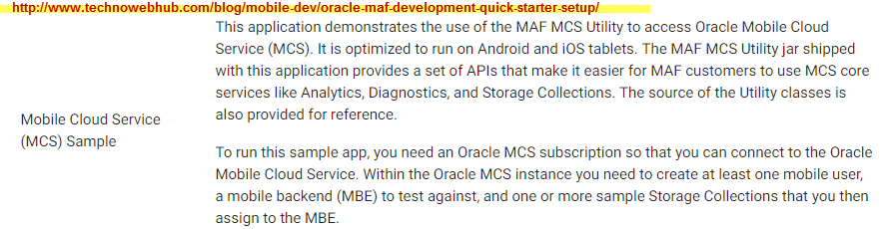

https://docs.oracle.com/middleware/maf220/mobile/develop-maf/GUID-8F1D2E01-06E6-4F6B-8AD5-A7888436AA2C.htm#ADFMF24182 (Error Handling)
http://prsync.com/oracle/quick-note-how-to-validate-an-input-field-in-a-list-view-801597/ (Validate – Error Handling)
https://blogs.oracle.com/mobile/entry/quick_note_how_to_validate (Validate a list view input field)
https://blogs.oracle.com/shay/entry/required_field_validation_in_oracle (Required field validation)
https://docs.oracle.com/middleware/maf232/mobile/develop-maf/GUID-40365F8F-B643-4770-BEF9-2A336E8BBB71.htm#ADFMF700 (Using Data Bindings, Validating)
https://docs.oracle.com/cd/E35521_01/doc.111230/e24475/amxui.htm#ADFMF696 (Validating input)
http://deepakcs.blogspot.com/2013_02_01_archive.html (ValueChangeEvent)
https://tompeez.wordpress.com/category/adf-faces-2/ (PopUp Event Listener)
C:\oracle\Demo\WorkBetter (For example of using a Web Service – EmployeeLoader.java)
http://docs.oracle.com/middleware/maf220/mobile/develop-maf/GUID-74D1067F-9040-4490-BA9A-172E376C478F.htm#ADFMF739 (Creating a Web Service)
http://prsync.com/oracle/how-to-create-a-select-one-choice-list-of-values-bound-to-the-amx-binding-layer-669233/ (Dropdown)
http://stackoverflow.com/questions/31537747/selectonechoice-is-not-able-to-cache-the-result-in-same-task-flow-in-oracle-maf (One Choice)
https://blogs.oracle.com/mobile/entry/accessing_selected_values_in_a (Selected row)
https://tompeez.wordpress.com/category/adf-faces-2/ (Current Row Index)
https://github.com/oracle/mobile-persistence/blob/master/Projects/Framework/Runtime/src/oracle/ateam/sample/mobile/v2/persistence/model/Entity.java (using getKey)

Unicode – UTF-8:
In an IDE such as Eclipse you can set the encoding at several places. You need to explore the IDE preferences thoroughly to find and change them. In case of Eclipse, just go to Window » Preferences and enter filter text encoding. In the filtered preferences (Workspace, JSP files, etcetera) you can select the desired encoding from a dropdown. Important note: the Workspace encoding also covers the output console and thus also the outcome ofSystem.out.println(). If you sysout an Unicode character using the default encoding, it would likely be printed as a plain vanilla question mark!
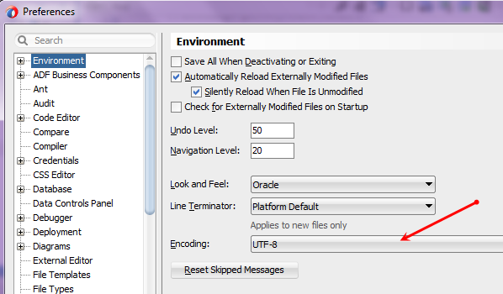
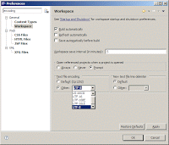

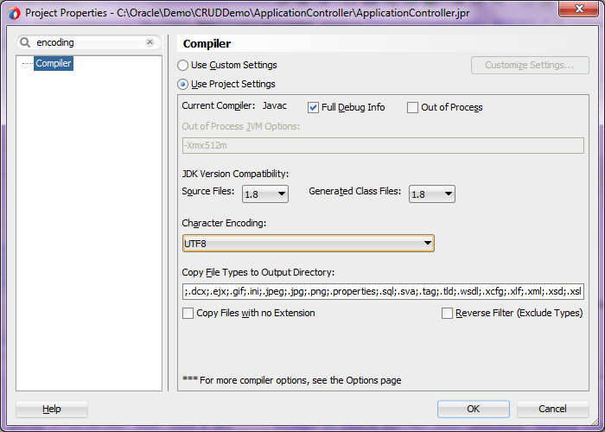
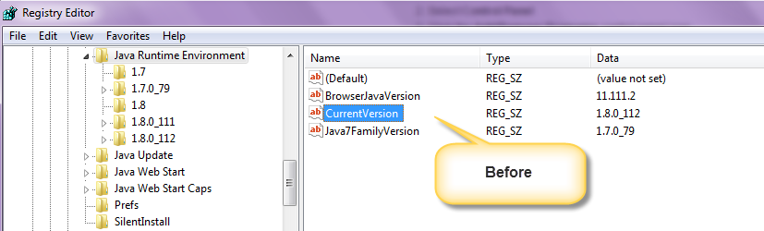

You have a requirement to open a url from your mobile app in mobile browser programmatically. In that case you can call a javascript function and use the below code:
if(device.platform == 'Android') {
navigator.app.loadUrl(url, {openExternal:true});
} else {
window.open(url, '_system');
}

PLUGINS
https://blogs.oracle.com/mobile/entry/integrating_a_custom_cordova_plugin
https://cordova.apache.org/docs/en/3.2.0/cordova/inappbrowser/inappbrowser.html#methods
http://stackoverflow.com/questions/16569269/handle-android-back-button-on-phonegap-inappbrowser
https://blogs.oracle.com/mobile/entry/opening_a_web_link_from (InAppBrowser)
https://docs.oracle.com/middleware/maf211/mobile/develop-maf/maf-ui-remote-url.htm#ADFMF23713 (Enabling the Browser Navigation Bar on Remote URL Pages)
http://docs.oracle.com/middleware/maf233/mobile/develop-maf/GUID-F38408E4-64B3-46C9-B1EE-CE19C75B3555.htm#ADFMF-GUID-4343E139-F6E6-4765-A182-A85786C0EC1B
https://blogs.oracle.com/mobile/entry/invoking_custom_javascript_from_an (Invoking custom Javascript)
https://blogs.oracle.com/mobile/entry/opening_a_web_link_from (Invoking custom Javascript)

AMX to HTML Page
http://www.johnbrunswick.com/2012/11/e2-0-workbench-podcast-9-adf-mobile-and-webcenter-content-simple-example/ (Master-Detail, Managed Bean)
https://sites.google.com/site/joeztechland/adf-mobile/adf-mobile-tips-and-tricks
https://community.oracle.com/thread/3687192 (iFrame)
http://docs.oracle.com/middleware/maf213/mobile/develop-maf/maf-about.htm#ADFMF24425
https://blogs.oracle.com/mobile/entry/opening_a_web_link_from (Cordova InAppBrowser)

https://www.numetriclabz.com/android-post-and-get-request-using-httpurlconnection/ (Configuring for INTERNET on Android)
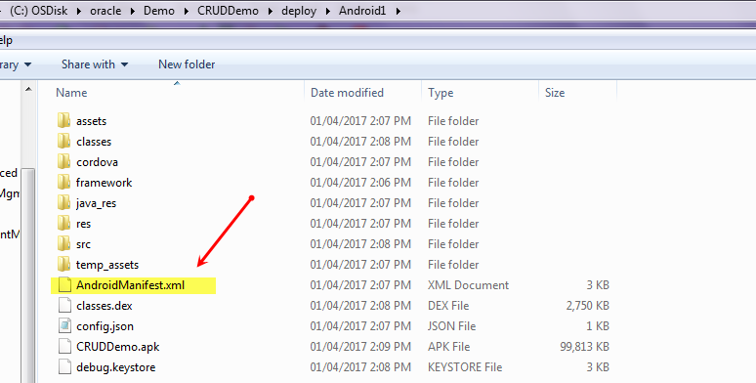
http://www.java2s.com/Tutorial/Java/0120__Development/ParseHTML.htm (HtmlEditorKit)

In order to develop web applications optimized for iPhone platform, you should own Apple MacBook

Master-Detail
http://andrejusb.blogspot.com/2014/07/adf-mobile-12c-maf-support-for-master.html
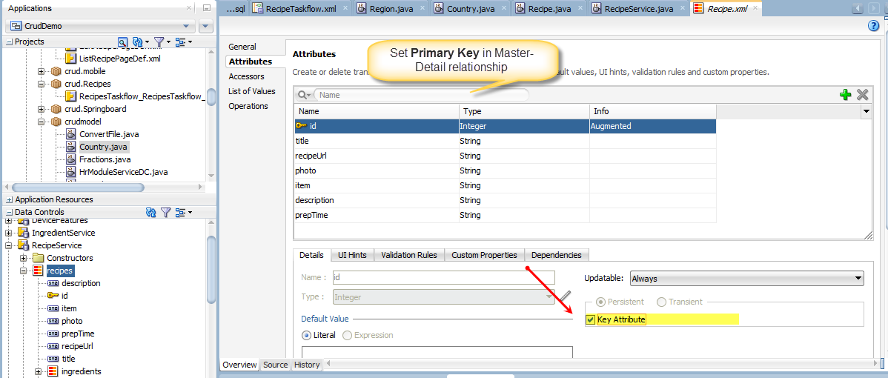

How to Add an External JAR file:
http://www.oracledistilled.com/java/adding-java-libraries-to-oracle-jdeveloper-11g-r1/
Right-click Application Controller, Project Properties
Right-click, View Controller, Project Properties

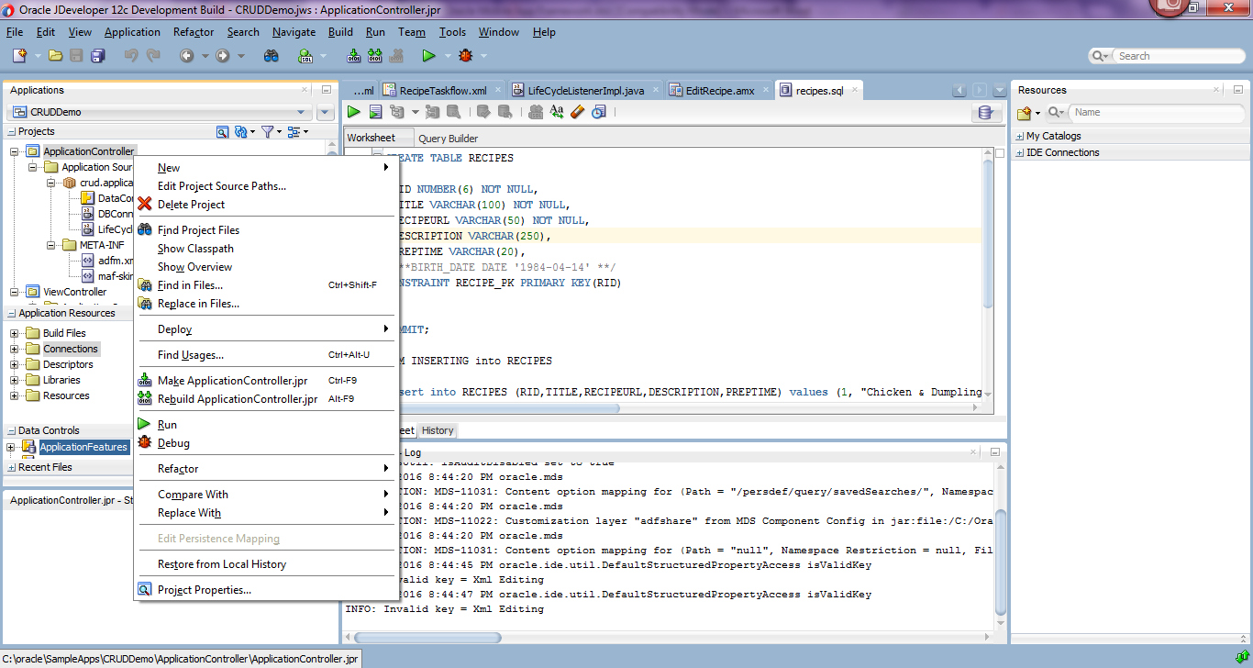

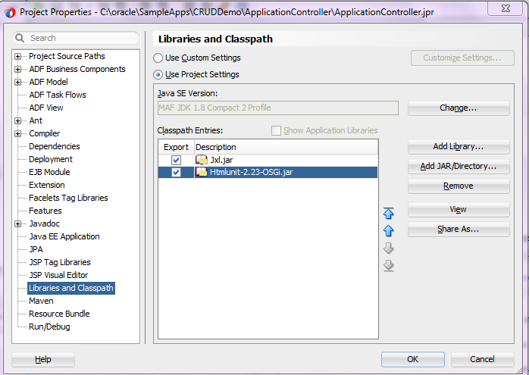
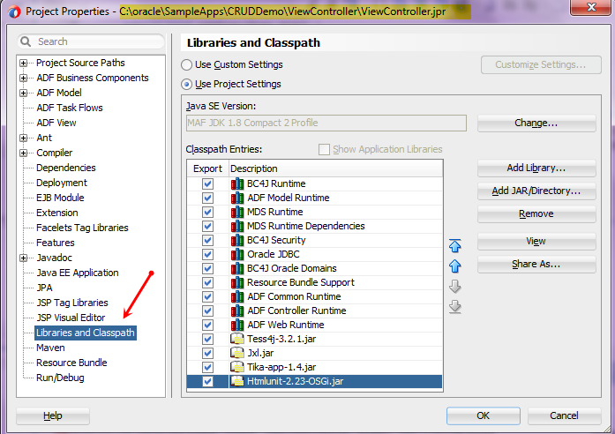

Oracle JDeveloper – Adding Java Libraries
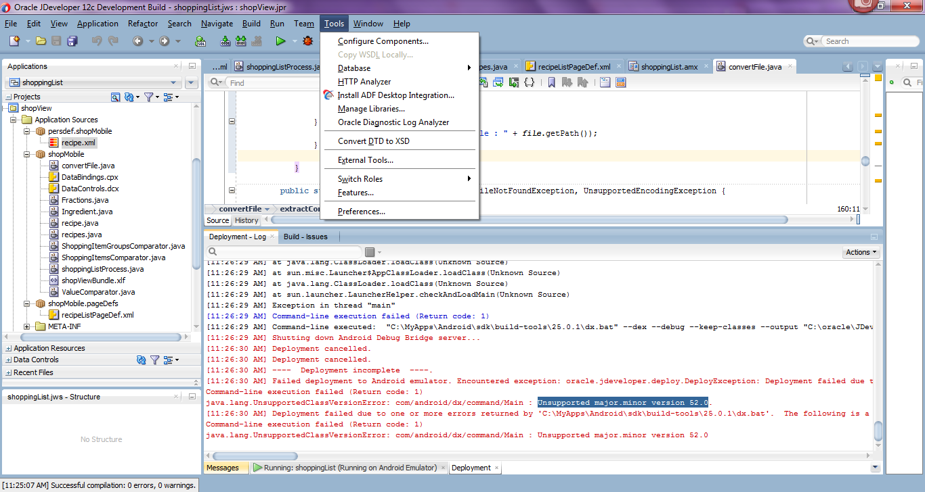

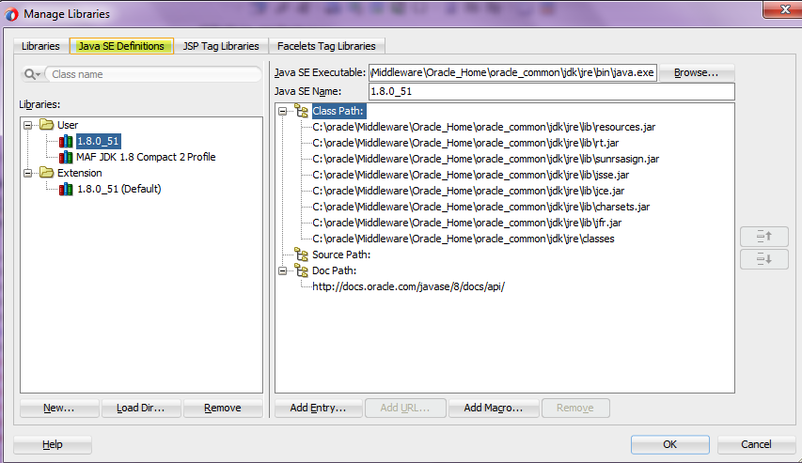
Also go to “Application Properties”
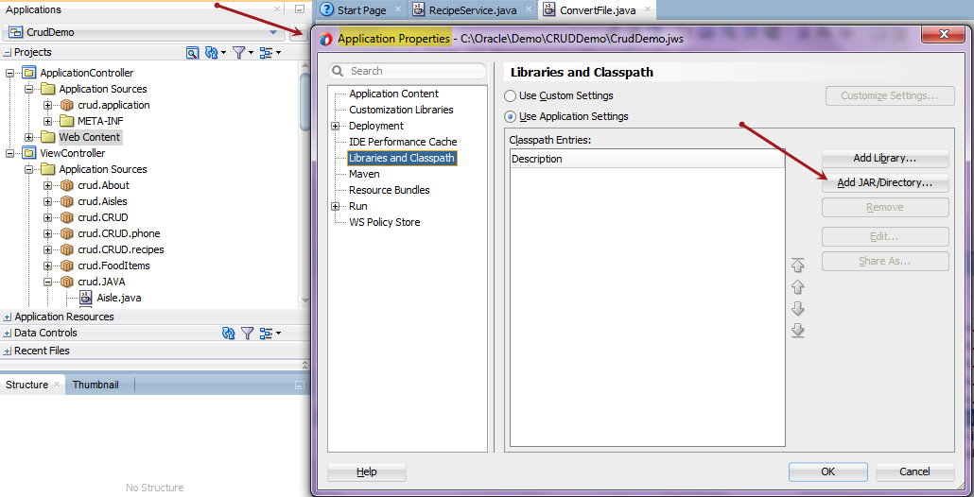

JAVA SETTINGS
JDEV_HOME:
C:\Oracle\Middleware\Oracle_Home\jdeveloper\jdev\bin
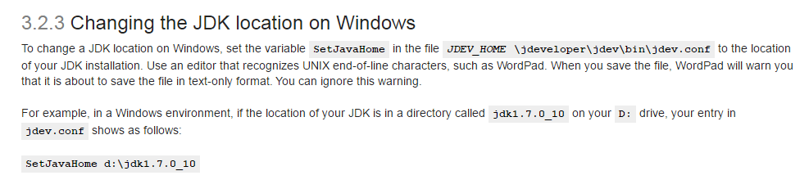
C:\Oracle\Middleware\Oracle_Home\oracle_common\jdk\bin
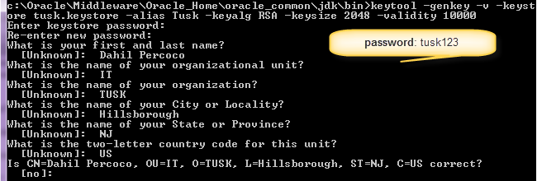

Eclipse IDE
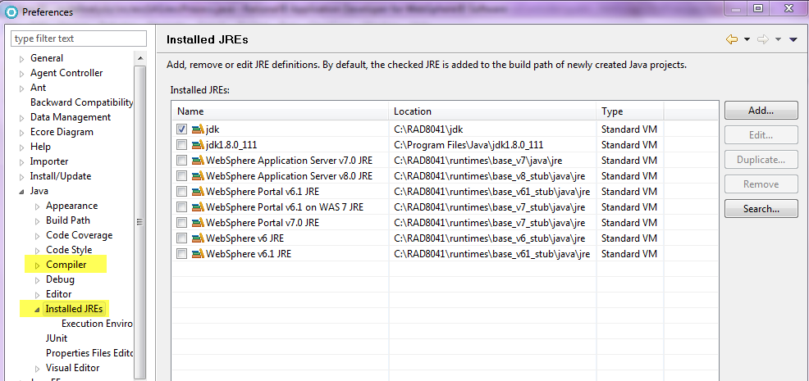

https://docs.oracle.com/middleware/1212/jdev/OJDIG/post_install.htm#OJDIG138
To increase heap size: http://stackoverflow.com/questions/3442323/java-lang-outofmemory-java-heap-space-jdeveloper
http://stackoverflow.com/questions/2540548/how-do-i-get-eclipse-to-use-a-different-compiler-version-for-java (Change Java Compiler)
https://docs.oracle.com/middleware/maf233/mobile/install/GUID-91DF0B93-265C-408B-8128-F0F3A1D91EC2.htm#MAFIG112
http://docs.oracle.com/cd/E53569_01/tutorials/tut_jdev_maf_app/tut_jdev_maf_app.html (Deployment)
https://www.youtube.com/watch?v=qj5kvlMKpAg (Binding Data Controls to Form Controls)
http://stackoverflow.com/questions/11229831/regular-expression-to-remove-html-tags-from-a-string
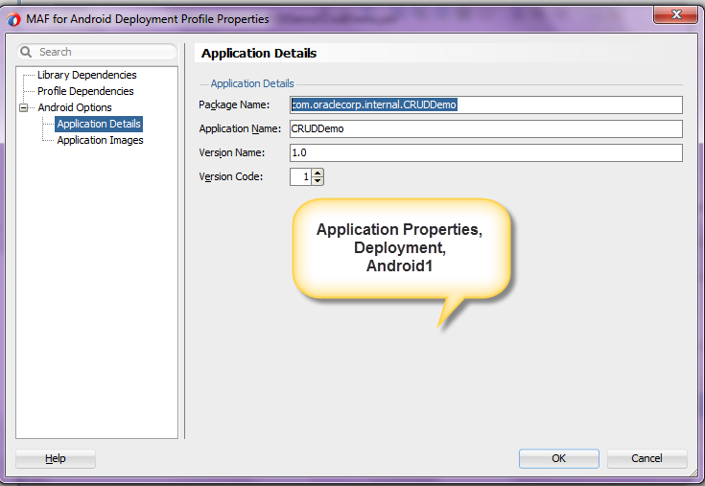

Android Studio
android-studio-bundle-145.3537739-windows.exe
http://tools.android.com/download/studio/builds/android-studio-2-2-3 (INSTALL)
https://software.intel.com/en-us/android/articles/installation-instructions-for-intel-hardware-accelerated-execution-manager-windows (HAXM)
https://support.lenovo.com/us/en/documents/ht117282 (BIOS Settings)
Project Structure:
Source: jdev_install - C:\Oracle\Middleware\Oracle_Home
jdev_install/jdeveloper/jdev/extensions/oracle.maf/Samples
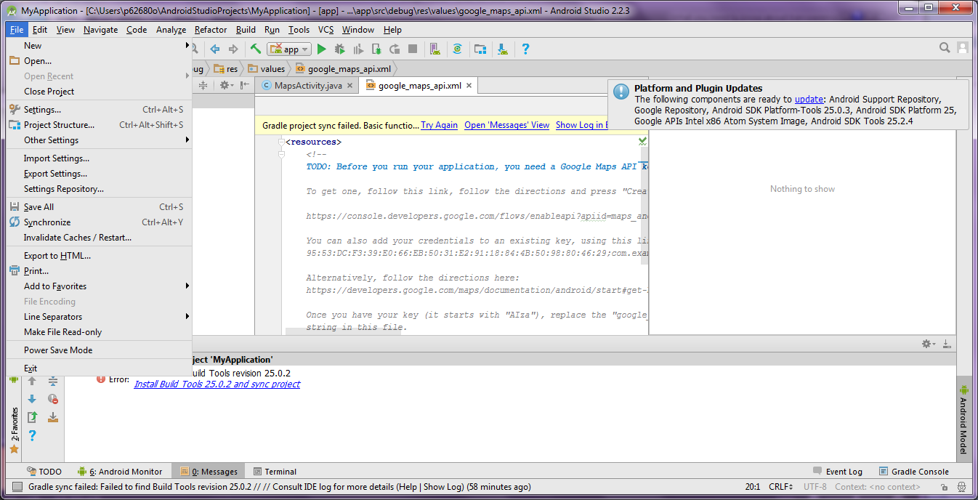
Android Studio, File, Project Structure
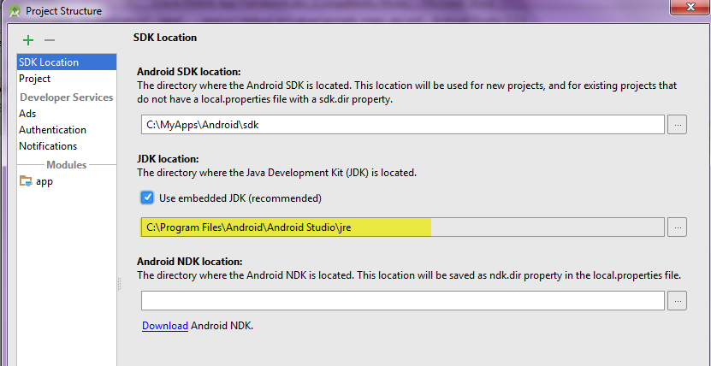
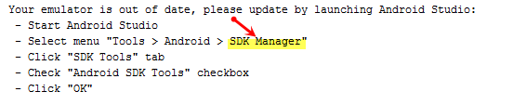
OR:
SDK Folder\SDK Manager.exe (JDeveloper, Tools, Preferences)
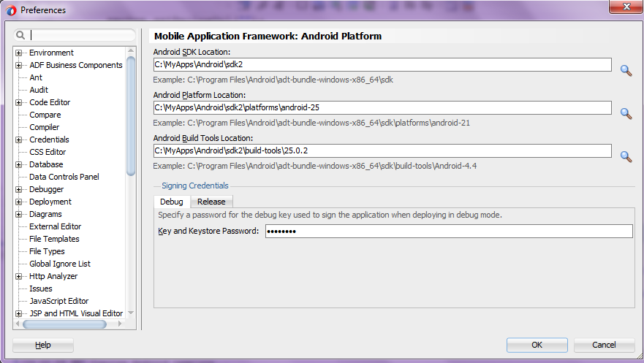
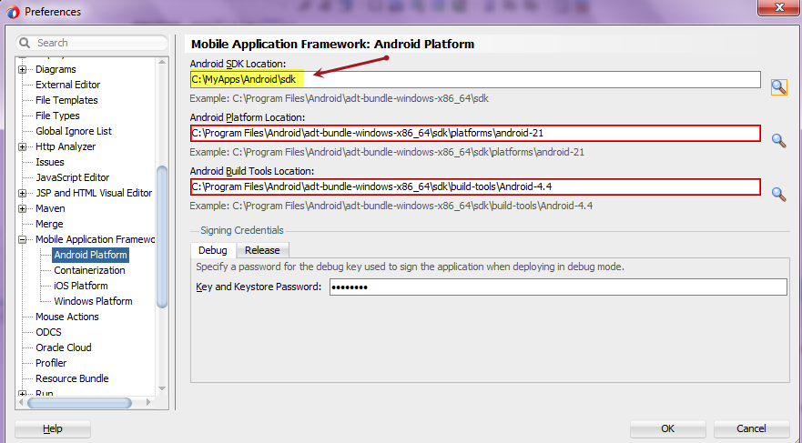
JDeveloper Program Flow:
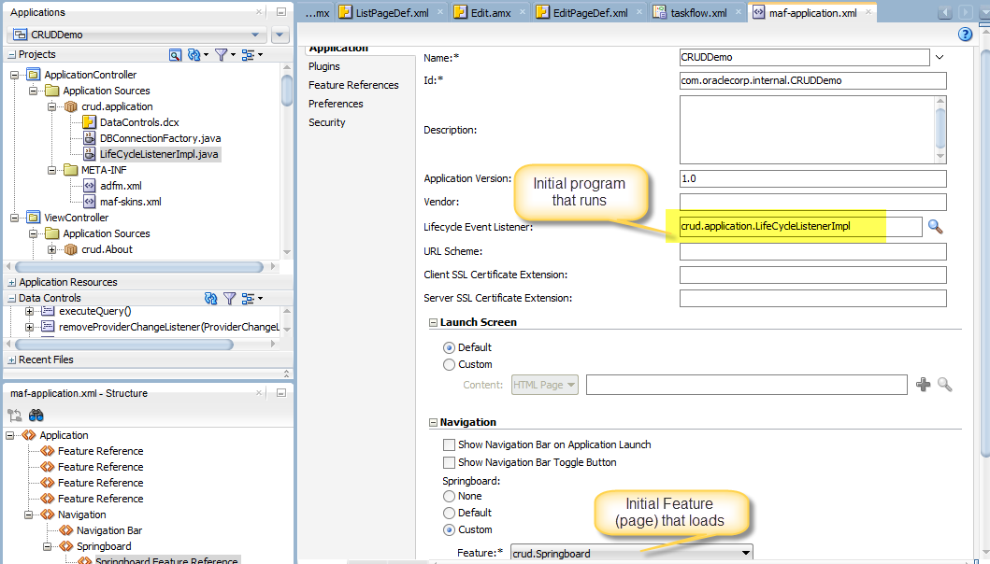
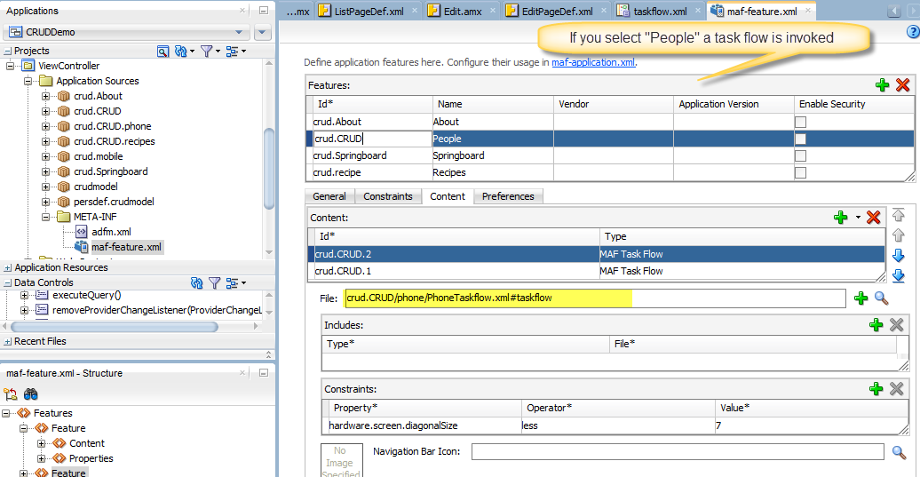
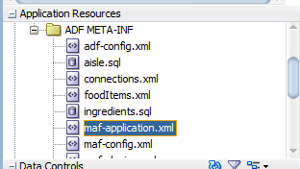
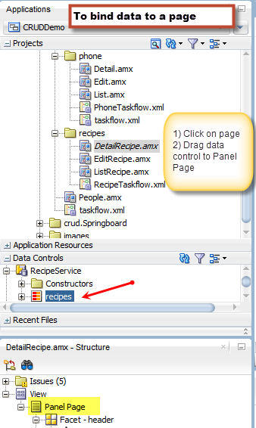
Spring Board
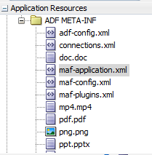
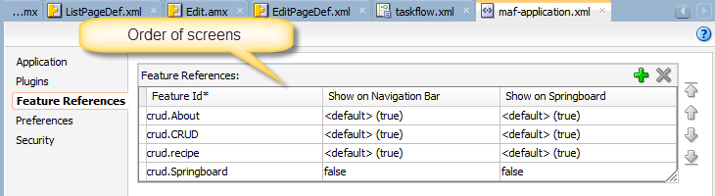

http://docs.oracle.com/cd/E53569_01/tutorials/tut_jdev_maf_app/tut_jdev_maf_app.html (Example)

Adding “Create” Method
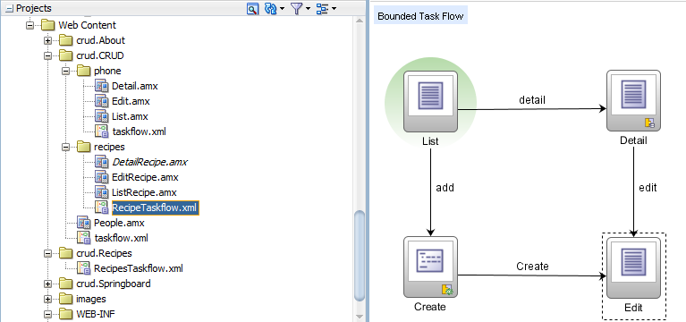

https://github.com/oracle/mobile-persistence/wiki/Using-the-Entity-Service-Data-Control (Operation: Create)
https://docs.oracle.com/middleware/maf231/mobile/develop-oepe/GUID-5B984654-52ED-4E54-8879-F44213506ED3.htm#OEPMF24692 (Create – addXXX)
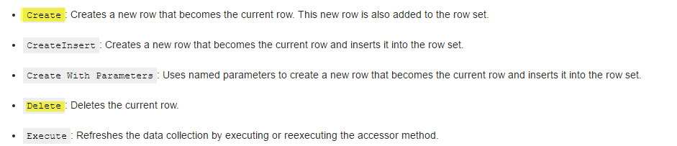
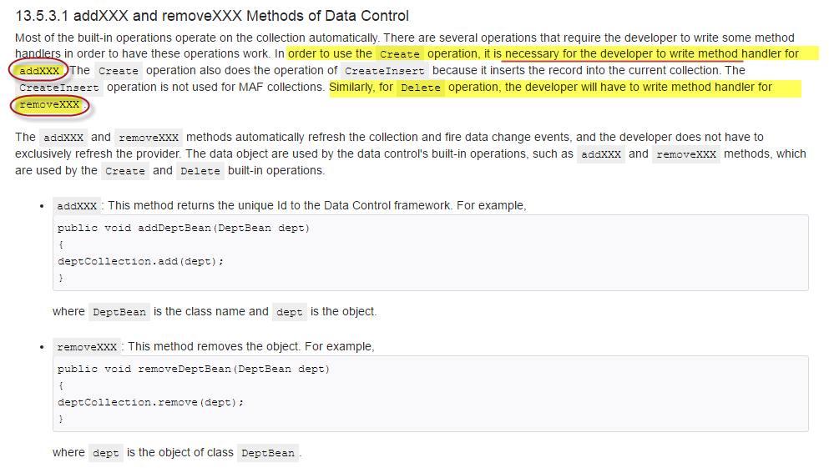
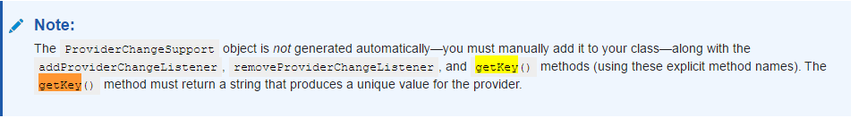

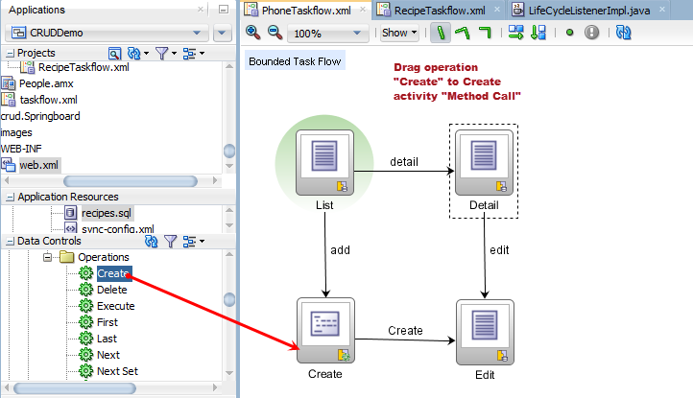
Bindings
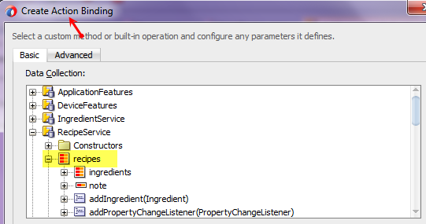
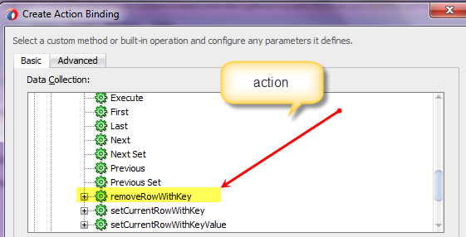
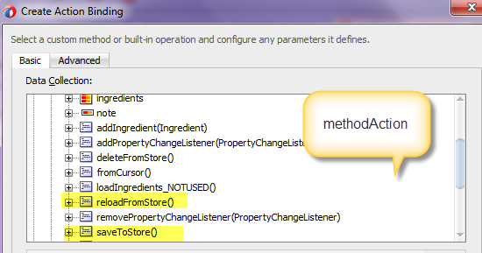

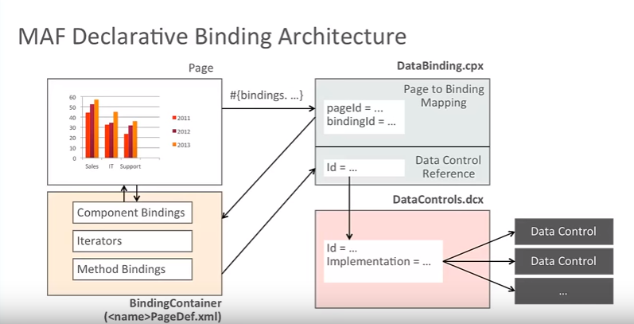
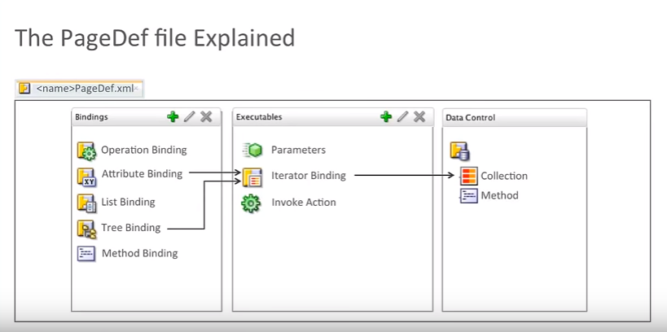

Error: The target maf-application.xml cannot be started because it is not a runnable target.
Resolution: Close ALL Pages, close application and re-open
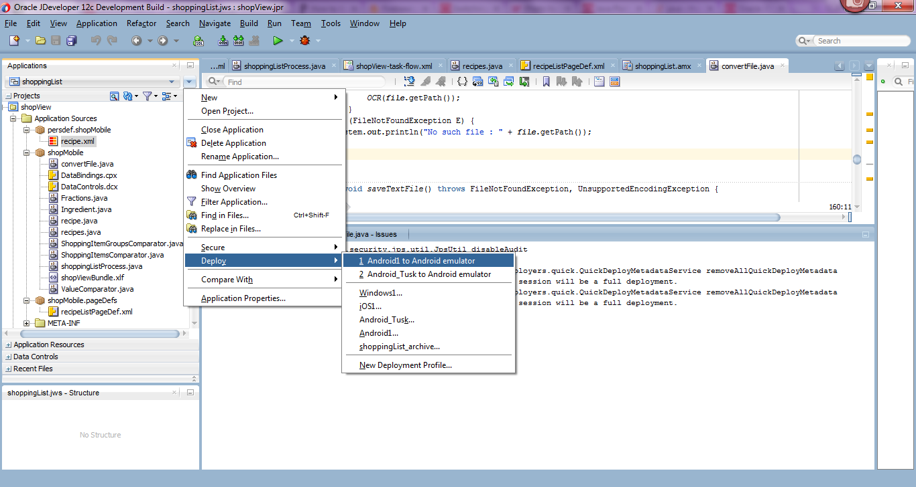
To run program in Emulator
http://www.epicurious.com/recipes/food/views/scrambled-eggs-with-lox-and-cream-cheese-718

<amx:facet name="secondary">
<amx:commandButton id="cb2" text="Add" action="goRouterAddOrDetail">
<amx:setPropertyListener id="spl1" from="#{'add'}" to="#{pageFlowScope.actionSelected}"/>
<amx:setPropertyListener id="spl1" from="#{'true'}" to="#{viewScope.backingPPR.showIt}"
type="swipeRight"/>

</amx:commandButton>
</amx:facet>
<amx:refreshContainer id="rc1" action="goFindAll" pullText="Pull down to refresh" busyText="Refreshing...">
<amx:listView var="row" value="#{bindings.employees.collectionModel}" fetchSize="#{bindings.employees.rangeSize}"
selectedRowKeys="#{bindings.employees.collectionModel.selectedRow}"
selectionListener="#{bindings.employees.collectionModel.makeCurrent}" showMoreStrategy="autoScroll"
bufferStrategy="viewport" id="lv1">
<amx:listItem id="li1" action="goRouterAddOrDetail">
<amx:outputText value="#{row.lastName}, #{row.firstName}" id="ot2"/>
<amx:setPropertyListener id="spl2" from="#{'detail'}" to="#{pageFlowScope.actionSelected}"/>
</amx:listItem>
</amx:listView>
</amx:refreshContainer>

